
Cloud Computing Lab

Submitted to:
Engr. Muhammad Shoaib

Submitted by:
Hania Akbar

Reg no:
2023-BSE-026

Section:
A

Lab 10 – GH CLI Codespaces + AWS + Terraform: CLI Automation of VPC/Subnet Creation

Task 1 — GitHub CLI Codespace Setup & Authentication
Goal: Install GH CLI (if not present), authenticate for Codespace use, and connect into the Codespace shell (all steps inside Codespace unless noted).
- Install GitHub CLI:
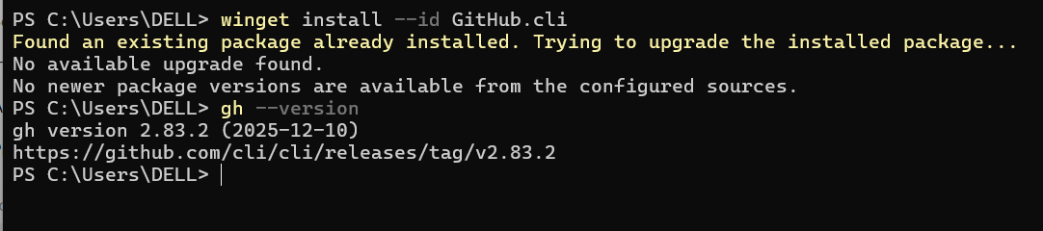
Authenticate GH CLI for Codespaces:
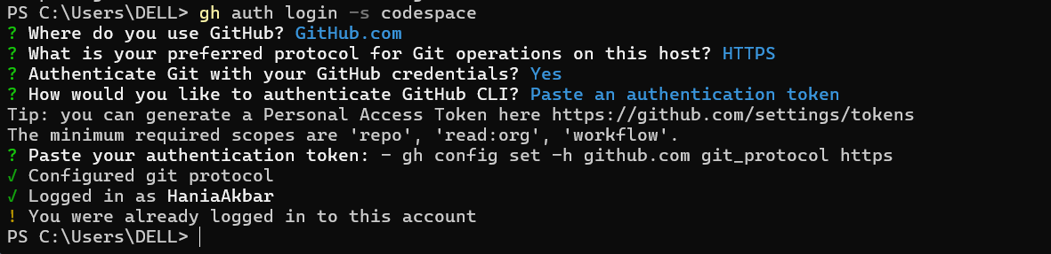
List available codespaces:
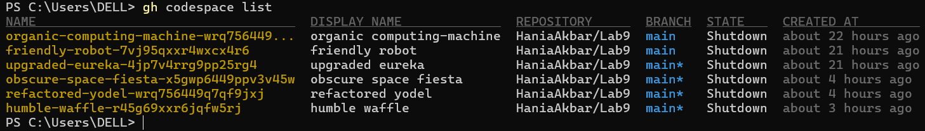
Connect to a codespace via SSH:
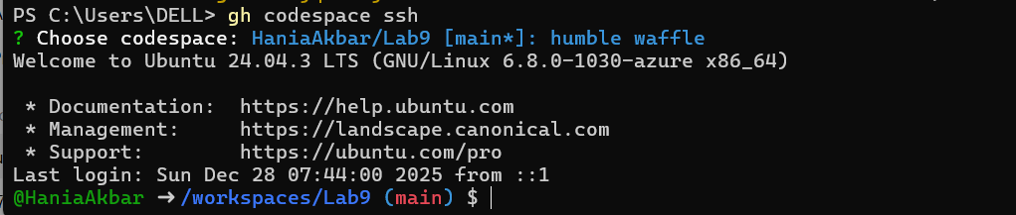

Task 2 — Install AWS CLI, Terraform CLI, Provider Setup
Goal: Install AWS CLI (if not present) & Terraform CLI inside Codespace; configure initial Terraform provider.

A. Install AWS CLI (Skip if already installed)
- In Codespace shell, install AWS CLI:
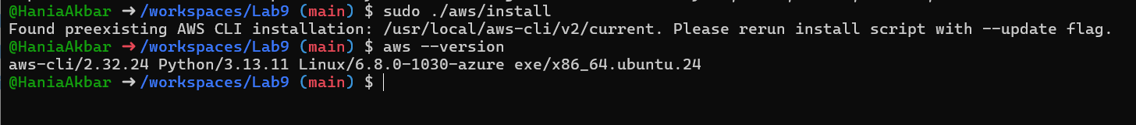
Configure AWS CLI:
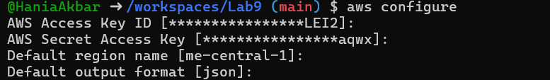
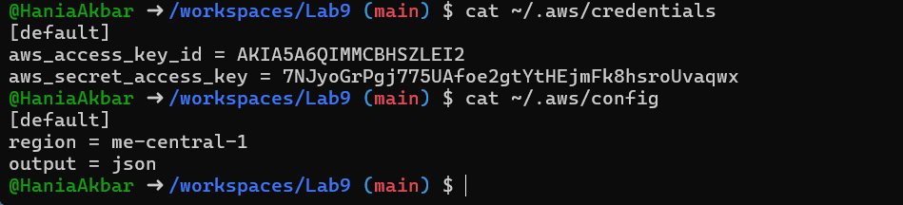
Verify AWS CLI connectivity:
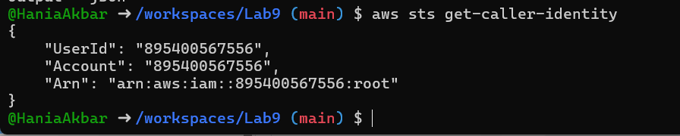

B. Install Terraform CLI
- Install Terraform CLI:

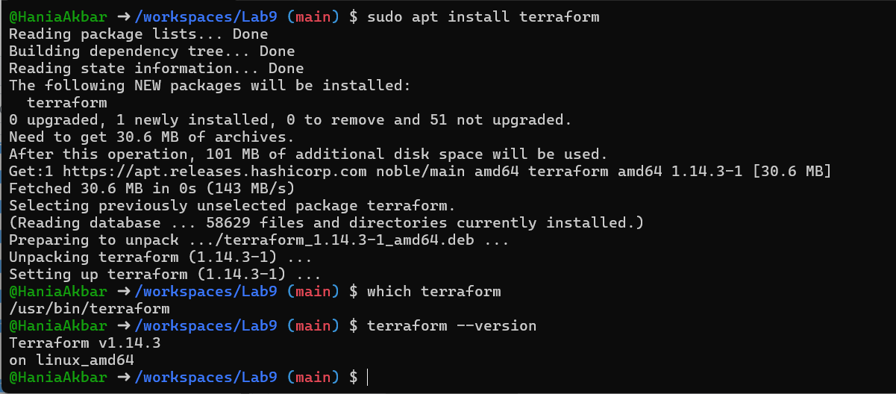

C. Provider Configuration (main.tf)
- Create main.tf using Vim:

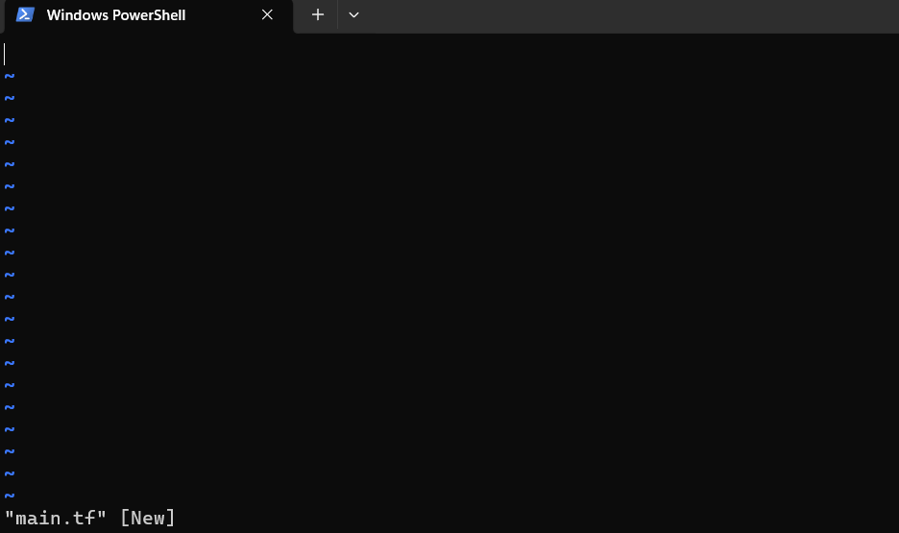

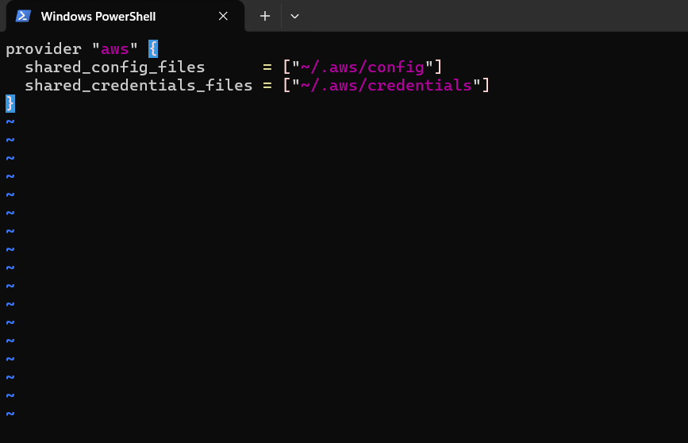
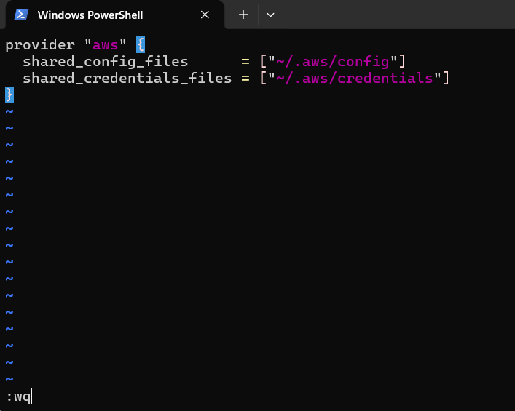

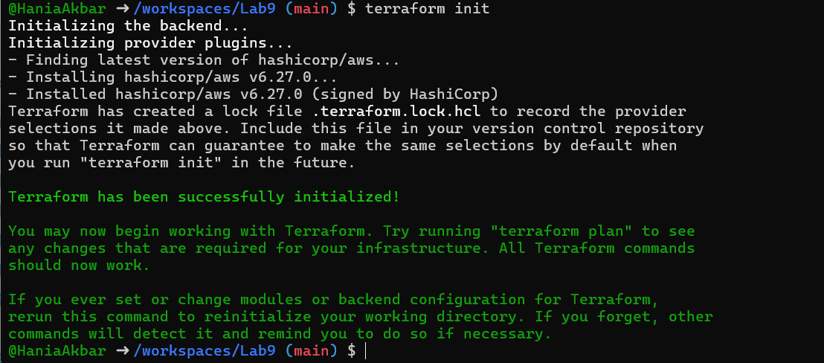
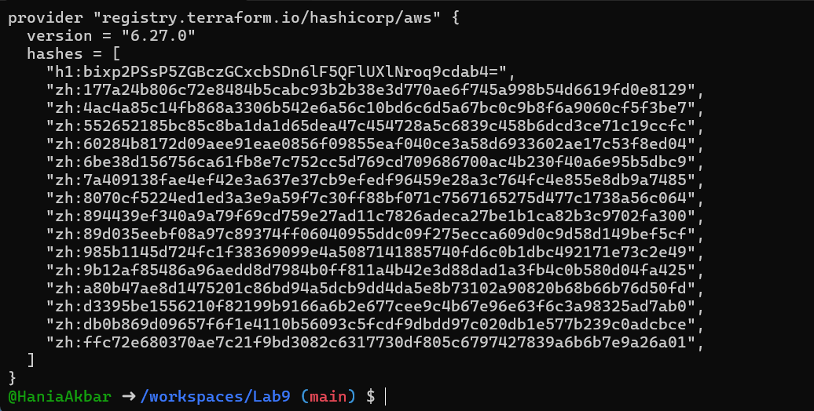
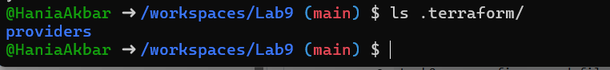

Task 3 — VPC/Subnet Creation, Initialization, Verification
Goal: Use Terraform to create VPC & Subnet resources, verify via CLI.
- Edit main.tf to add:
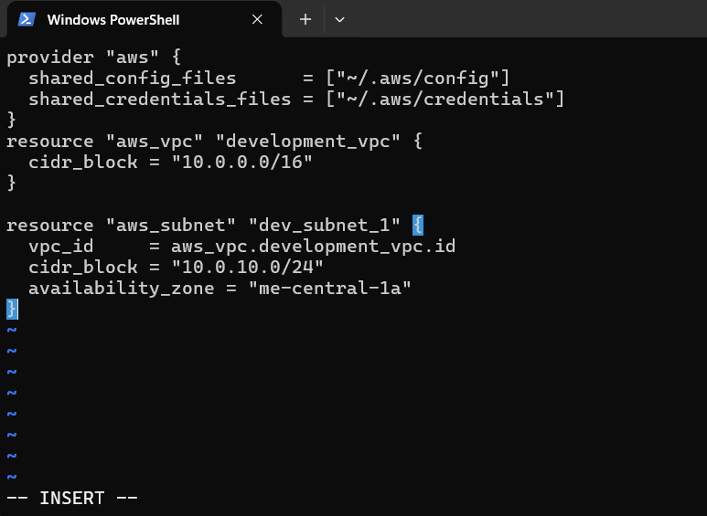
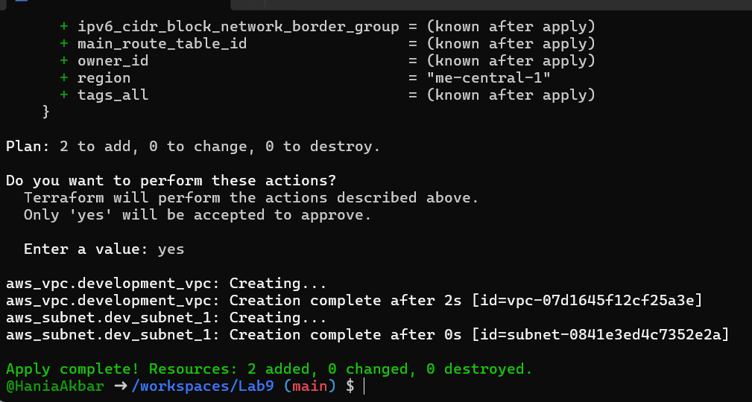

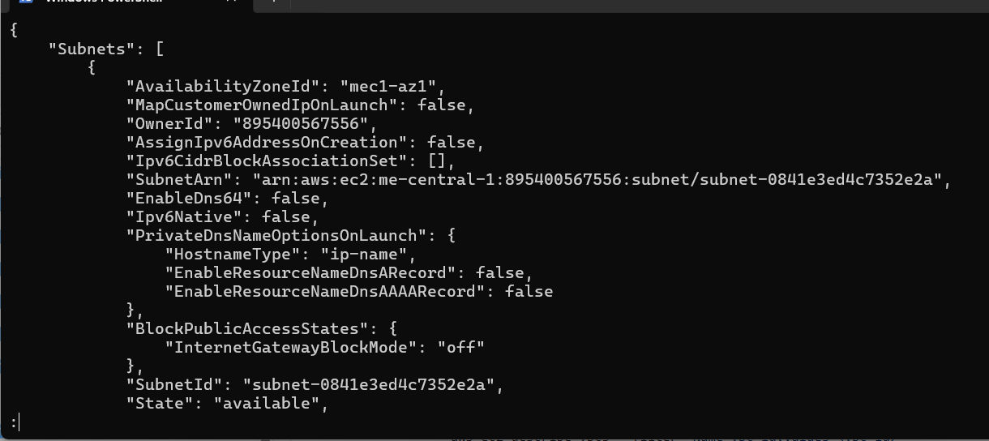

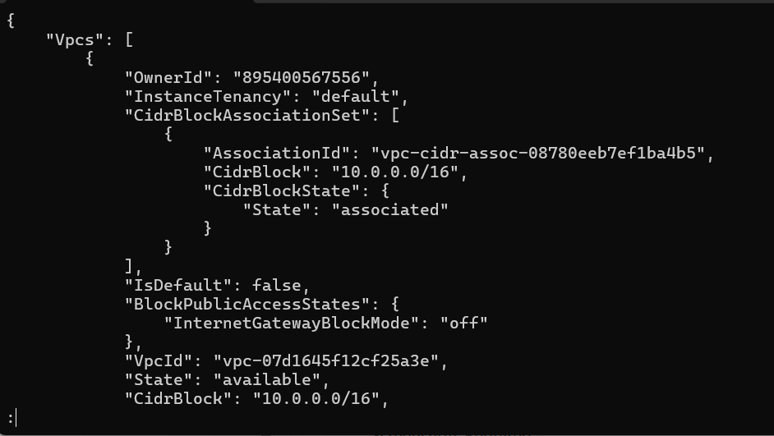

Task 4 — Data Source, Targeted Destroy, Tags

A. Data Source & Resource Creation
- Add to main.tf:

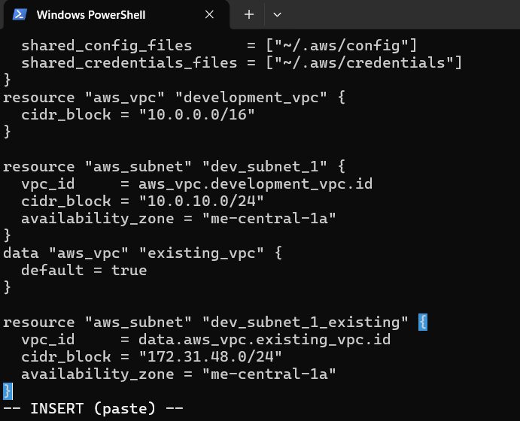

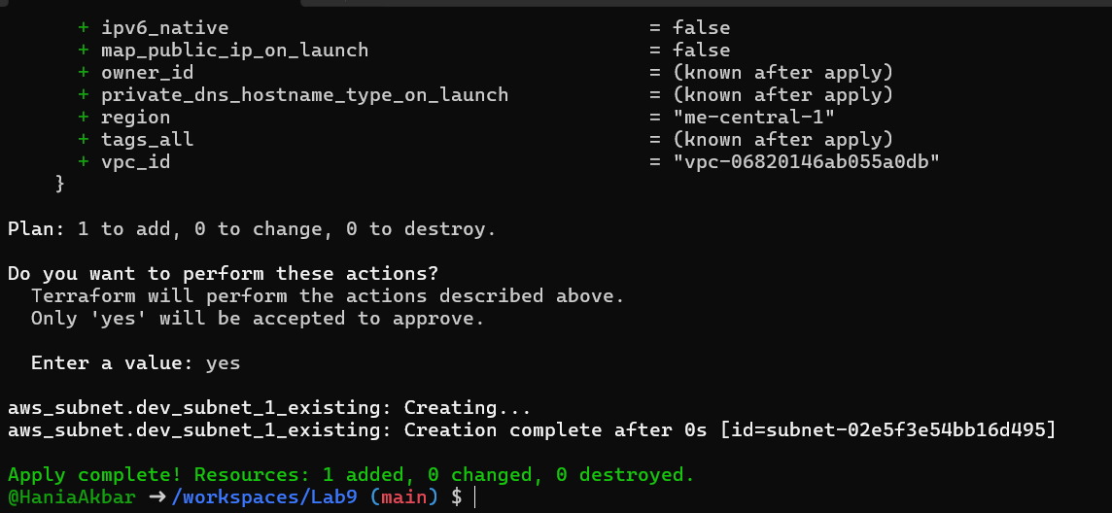

B. Targeted Destroy & Refresh
- Destroy only one resource:
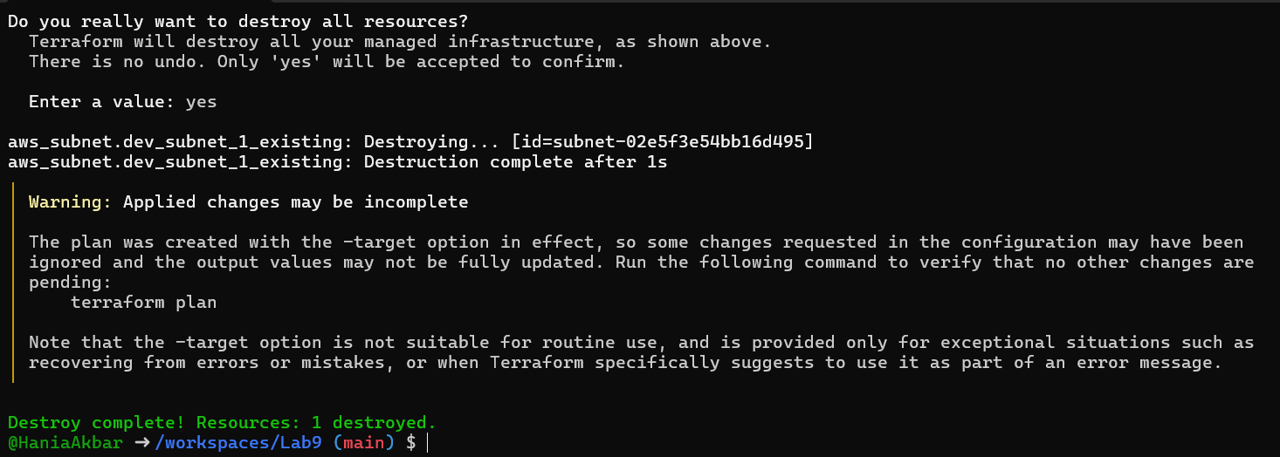

Refresh state:
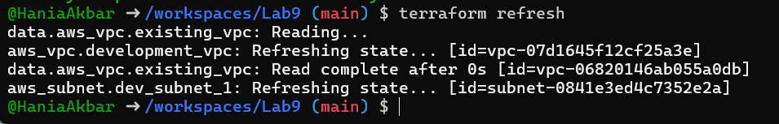
Re-apply configuration:
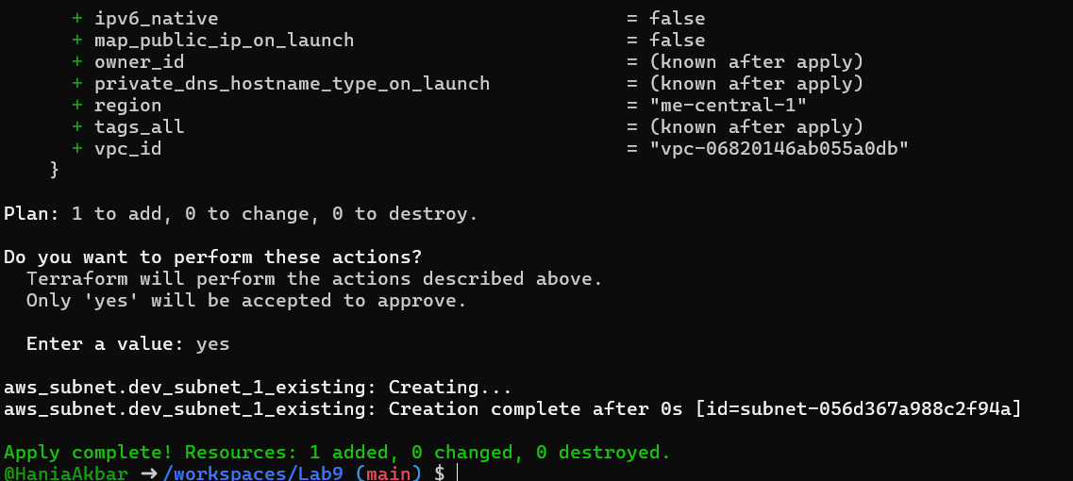
Destroy all resources:
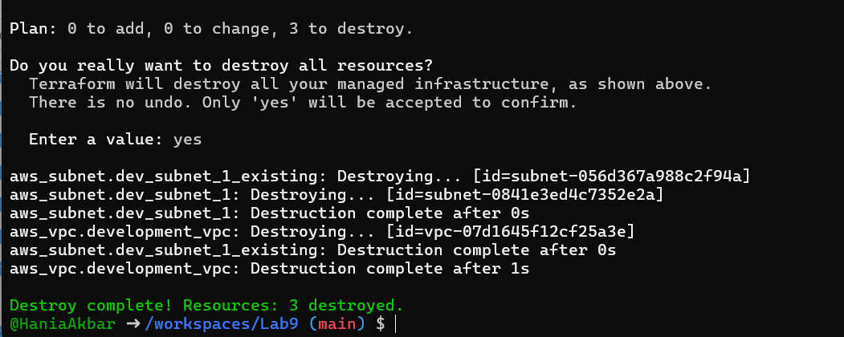
Plan configuration:
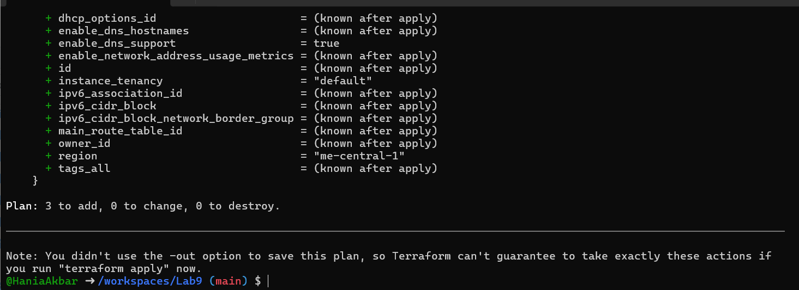
Apply again:
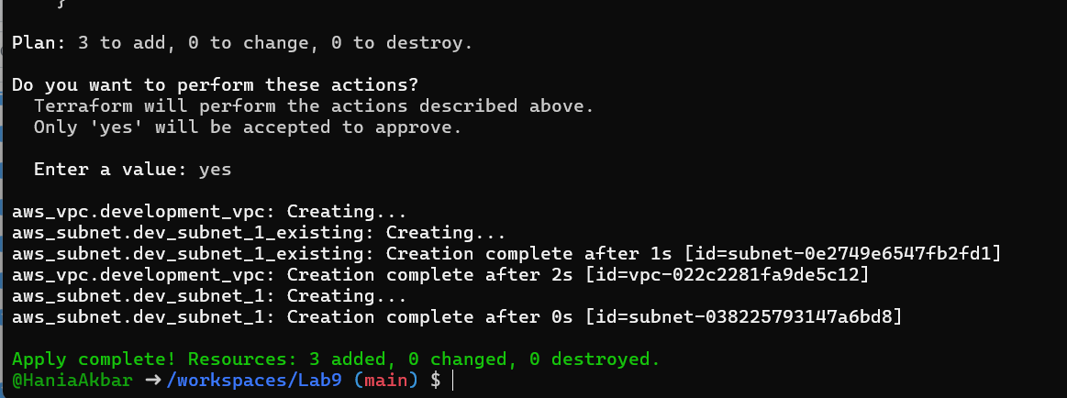

C. Tagging Resources
- Modify main.tf to add tags:
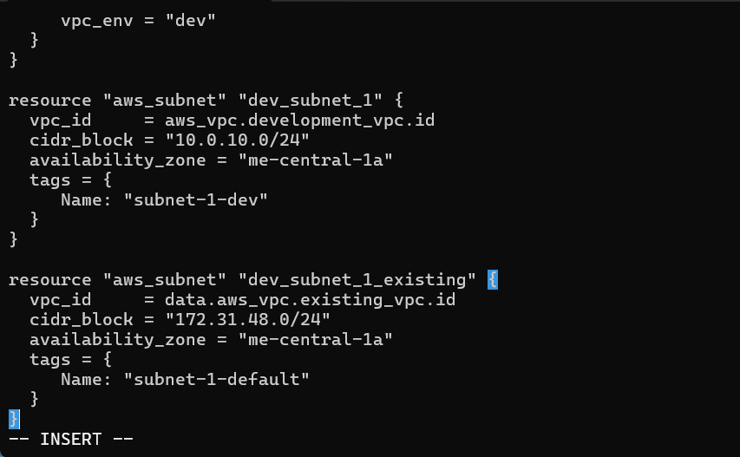
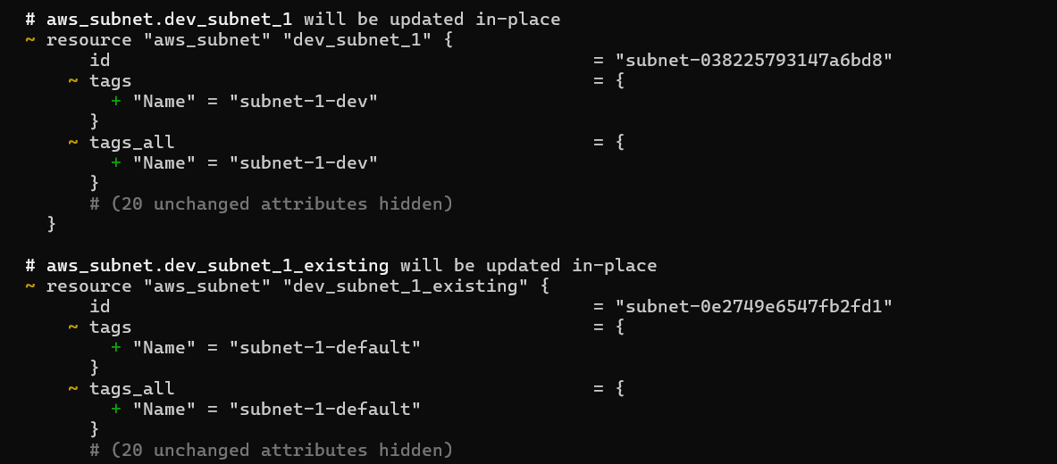

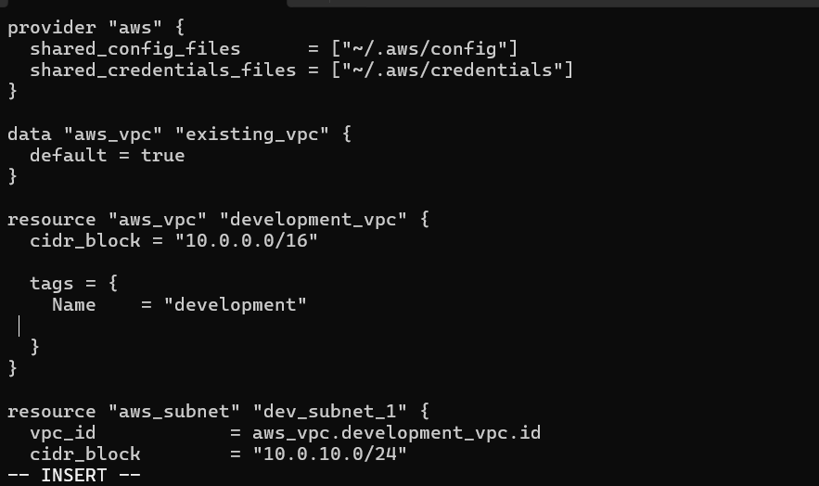

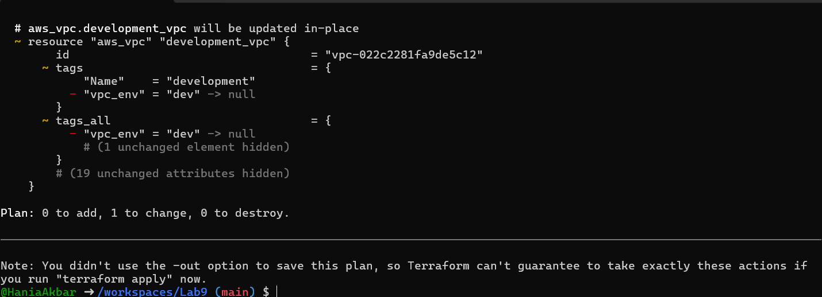

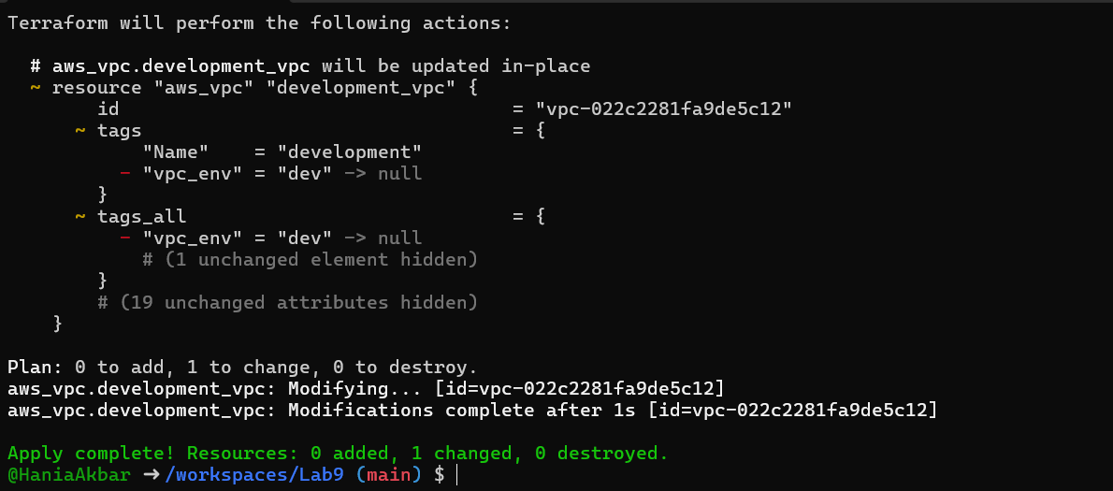

Task 5 — State File Inspection & Terraform State Commands
- Destroy all resources:
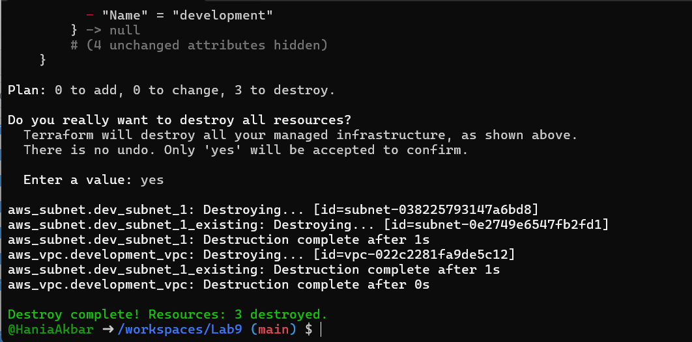

Inspect state files after destroy:
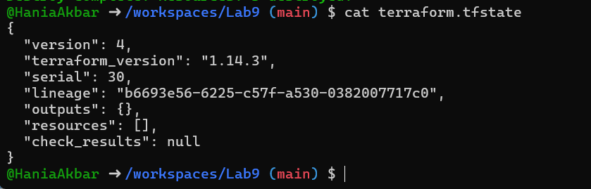
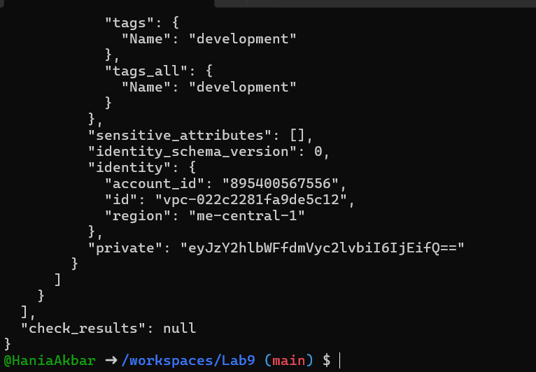

Recreate resources:
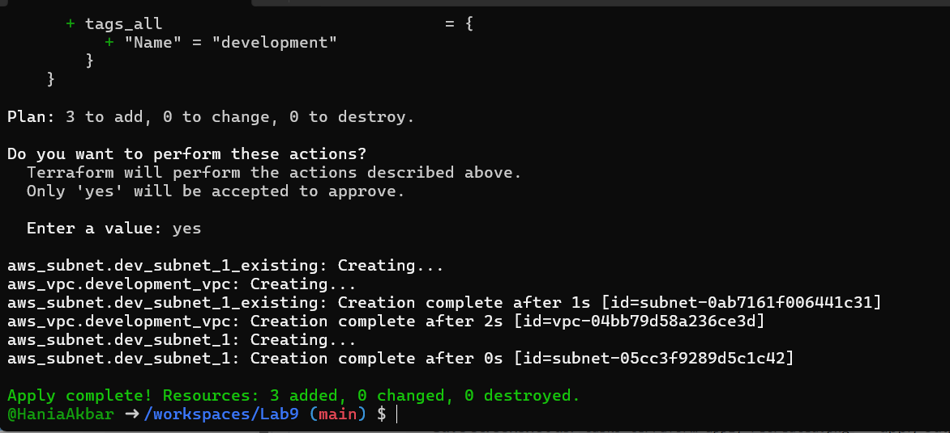

View state files:
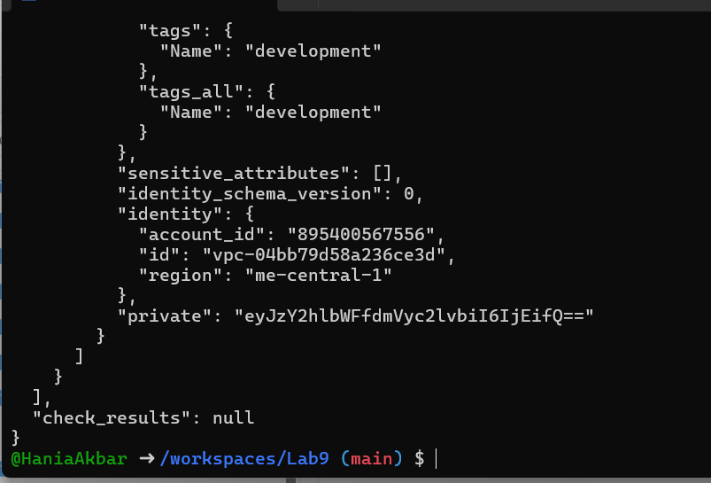

List resources:
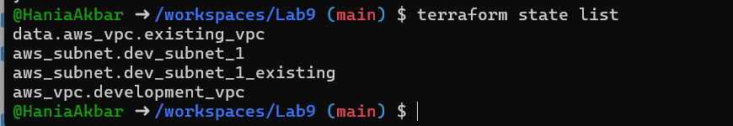

Show full attributes:
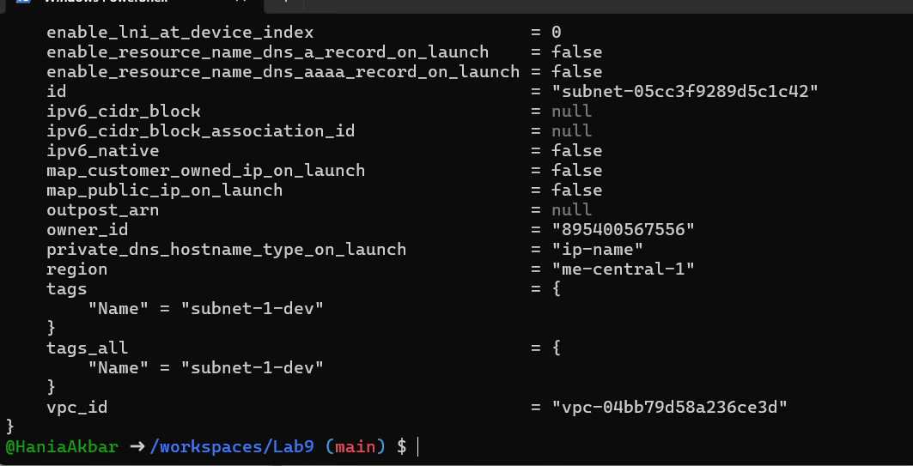

Task 6 — Terraform Outputs & Attributes Reporting
- Add outputs in main.tf:
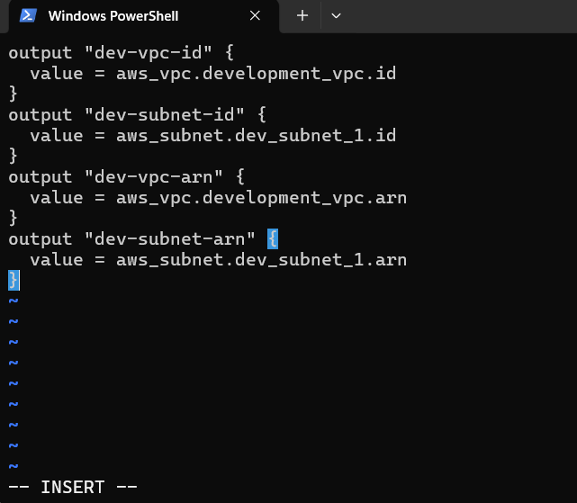

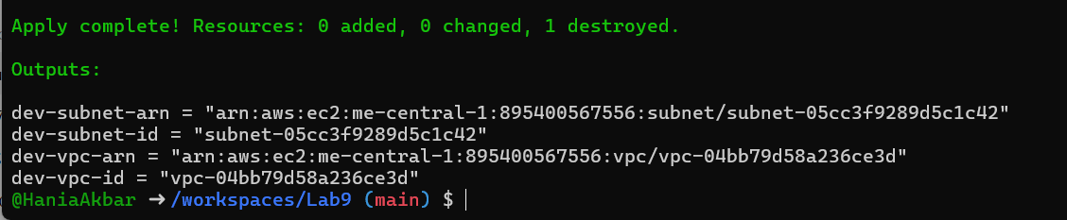

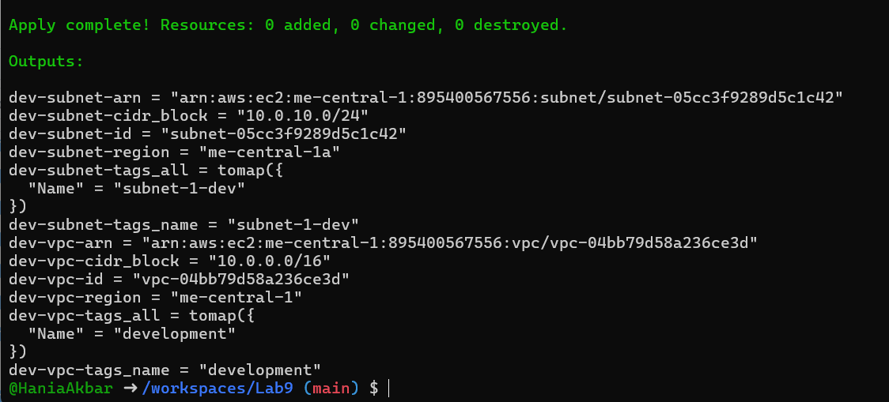

Cleanup — Delete Resources & State Verification
- Destroy all resources:
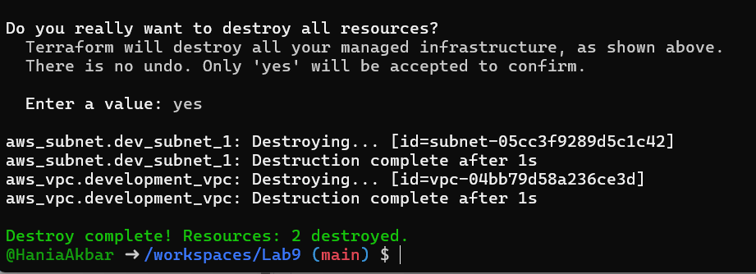
Inspect state files:
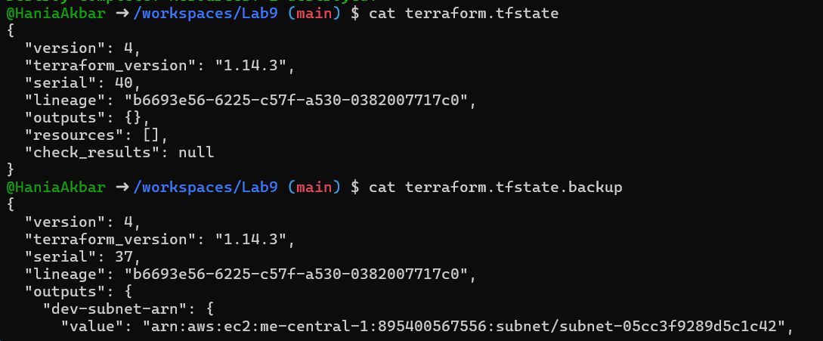
- Reapply then compare state and backup files to see differences.

